**IEEE-Project Support M-Tech**

Cloud Technologies is an ISO 9001:2015 Certified Company and is internationally established software Development Company with office in India. Our development center is located in a state-of-art facility in the heart of Hyderabad; Established in 2012.Cloud Technologies is a software development center with mission of providing innovative services and vision of serving clients across the world. Cloud Technologies is customer centric Information Technology Company and We specialize in cloud computing and we offer a highly customizable and scalable Services.

Till Now We have Trained More than 50,000 Students across the world in different Stages of Academics with a Positive Feedback over the entire web

* **GOOGLE Rated Us with 4.8/5 Stars**
* **FACEBOOK Rated Us with 4.7/5 Stars**
* **JUST DIAL Rated Us with 4.4/5 Stars**
* **SULEKHA Rated Us with 4.5/5 Stars**
* **EDUGORILLA Rated Us with 4.9/5Stars**

**Our services**

1. Software Services
   * 1. Responsive web design and development.
     2. Android Mobile Apps design and development.
     3. IOS Mobile Apps design and development.
2. Digital Marketing
   * 1. SEO.
     2. SMO.
     3. SMM.
3. Academic Services
   * 1. IEEE Papers Development.
     2. M-Tech Projects Development.
     3. B-Tech Major Projects Development.
     4. Mini Projects Development.
     5. Paper Publishing In UGC Approved Journals.
     6. Cloud Computing Papers In Really Time Cloud Data Base
     7. Cloud Computing Papers Using AMAZON WEB SERVICES(AWS)
     8. Plagiarism Free Document Support with license Checker

**IEEE DOMAINS WE SUPPORT**

* Cloud Computing
* Cloud Storage
* Cloud Security
* Data Mining
* Mobile Computing
* Secure Computing
* Networking
* Information Security
* Information Forensics and Security
* Computers
* Services Computing
* Knowledge and Data Engineering
* Parallel and Distributed Systems
* Cybernetics Systems
* Dependable and Secure Computing

We are specialized on Java, Dot Net, PHP &android technologies.

Cloud Computing Papers in Really Time Cloud Data Base and AMAZON WEB SERVICES (AWS)

Cloud Technologies is affiliation partner with following Group of Journals

1. EDUPEDIA PUBLICATIONS PVT. LTD
2. SEMAR GROUPS
3. TECHNO SCIENCE ACADEMY
4. I2OR PUBLICATION SERVICES LLP
5. INTERNATIONAL JOURNAL FOR MODERN TRENDS IN SCIENCE AND TECHNOLOGY
6. INTERNATIONAL JOURNAL FOR INNOVATIVE ENGINEERING AND MANAGEMENT RESEARCH
7. SK RESEARCH GROUP OF COMPANIES

**IEEE PROJECTS COST & SUPPORT**

|  |  |  |
| --- | --- | --- |
| **Project Cost & Support-1** | | |
| 1 | Project Code-In java & Support (from our List of projects only). Output as Per Video | **8000 RS/-** |
| 2 | Project Code-In Python & Support (from our List of projects only). Output as Per Video | **10000 RS/-** |
| 3 | Paper Publishing from our List of journals, including UGC & UGC-CARE Group 'A' Journals. Minimum charge: | **5000 RS/-** |
| 4 | Paper Publishing in **scopus** Journals. | **Starts from 15000 /-** |
| 5 | Plagiarism Free Document as per your requirements, Plagiarism Checker X report / DrillBit(licensed version software). | **5000 RS/-** |
| **Other Services Cost & Support** | | |
| 6 | Project Enhancement/Modifications | **Charges Extra** |
| 7 | Real Time Cloud (Cloud MYSQL Data Base)  Cloud Means Only The Data Base will upload in Cloud, not the Application | **1500/- RS(Development Charges)**  **Aprox 700/- RS sever cost.** |
| Cloud MYSQL Link(Only Data Base) | <http://www.cloudaccess.net/> |
| 8 | Amazon web services (AWS). Total Project deploy in online Using AWS | **5000 RS/- (Development Charges)**  [**https://signin.aws.amazon.com/signin**](https://signin.aws.amazon.com/signin) |
| Live Projects in AWS Please Check the URL | <http://cloudstechnologies.in/IEEE-CloudComputing-AWS-ojects.aspx> |

**What You Get**

* Abstract
* IEEE Base paper
* Source Code
* Data Base Backup
* Document
* Video
* Project Needed Software’s
* Explication & Execution Support Both online & offline.

**Document You Get**

1. NEW PROJECT NAME
2. ABSTRACT
3. EXISTING SYSTEM
4. PROPOSED SYSTEM
5. IMPLEMENTATION MODELS
6. INTRODUCTION
7. PROJECT ARCHITECTURE DIAGRAM
8. FUNCTIONAL REQUIREMENTS
9. NONFUNCTIONAL REQUIREMENTS
10. LITERATURE SURVEY
11. DESIGNING (9-UML,1-DFD,1-ER-DIAGRAM)
12. INTEGRATION TESTING
13. VALIDATION TESTING/TABLES
14. COMPATIBILITY TESTING
15. SCREEN SHORTS
16. CONCLUSION
17. REFERENCES

**Note: -Support Still External Viva**

**AWS-RDS Free Account**

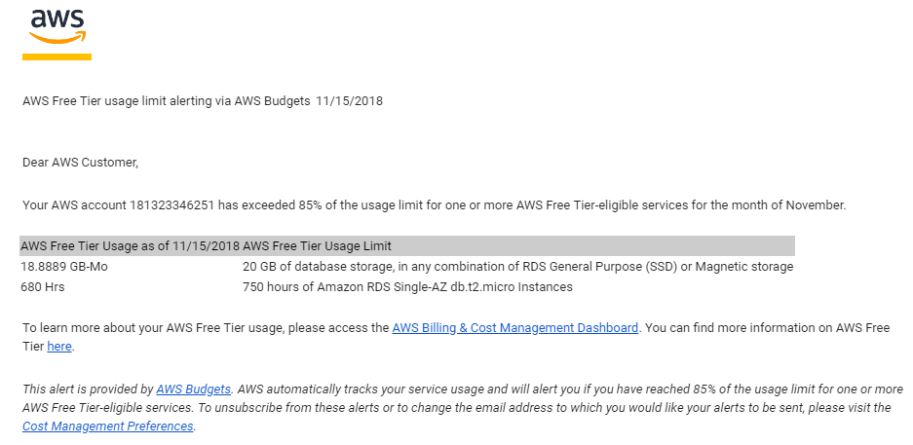

**NOTE:- for any type of Bills Generated By AWS Cloud Technologies is not Responsible all at your owner Risk only AWS account Have to be Created by Students only**

**HOW THE PROJECT RUN IN CLOUDACCESS**

